Kind Regards,
  - 10 Page Game Design Document

Brian Vlaar
Dylan Pipping
Isabel Pijnenburg
Jasper Sijben
Patrick van Halm
Sander Theeuwen
Mobile, rated PEGI 3
To be released on 21-1-2022
Contents
Gameplay 3
USP (Unique Selling Points) 3
Game Flow 3
Primary game loop 3
Secondary game loop 4
Companion 4
Controls 5
Platform 5
Main Gameplay Concepts 5
Genre 5
Setting 5
Game World 5
Mood 5
Theme 6
Mechanics 6
Dynamics 6
Aesthetics 6
Stickers 6
Cutscenes 8
Similar Products 8
Inspiration 8
Literature List 10

Gameplay
In Kind Regards, the player can send out their problem based on predefined choices. Other players can then react to the request with a motivational message chosen from a list and an optional gift. If a player chooses to send a gift, they select a sticker from their unlocked stickers which they want to give the player. The player can also personalize the gift by changing the color of the gift and ribbon. The player’s companion, the owl, will deliver the gift to the requester upon sending. In return, the recipient can “thank” the sender, by sending a heart, to let them know they appreciate the gift they have received. All messages received, will end up in the recipient's mailbox. The mailbox can be viewed anytime by the player to look back on received messages. When the player gets a sticker out of a gift that they have not received yet, this sticker will then be permanently unlocked for them to use in future gifts.
Players can write down everything that comes to their mind in the personal diary. Only the player can see their personal diary. These diary entries can consist of the player’s overall feeling, represented by a smiley: sad, neutral, or happy. The player can also add a message they write themselves, and stickers they unlocked through gifts. The player can also add a diary entry by just tapping a smiley without writing about their day or clicking a smiley without writing the entry itself.

USP (Unique Selling Points)
- Communication with others without the dangers of bullying.
- Cute sticker collectables.
- Appreciation to other users.
- A safe space with anonymity as a baseline.

Game Flow
The game flow is based on a model (see figure 1) which is composed of the following components:
Action: What does the player do?
Reward: What does the player get for performing the action?
Expansion: What can the player do with the reward?
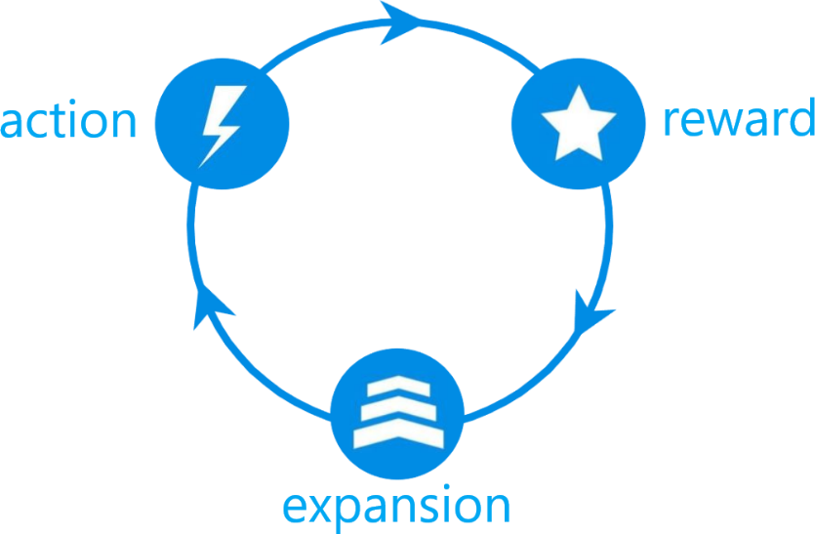
Figure 1 Core loop components¹

Primary game loop
Action: Sending and receiving a gift (see figure 2).
Reward: Receive a sticker from the gift and/or receive a heart emoji for appreciation for the sent message.
Expansion: Unlock a new sticker that the player can use to send in a new gift.

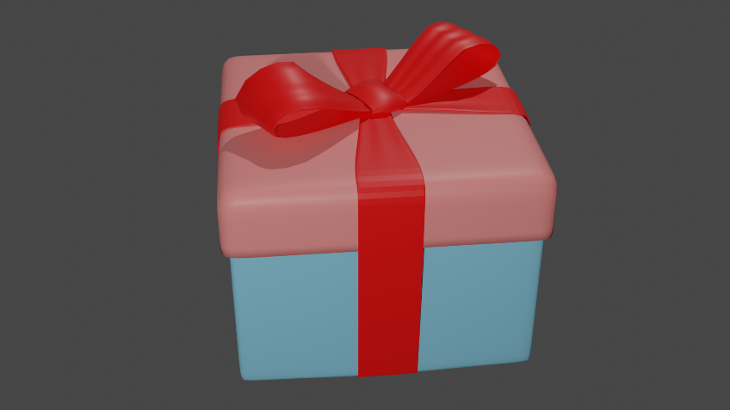
Figure 2 Example of a gift²

Secondary game loop
Action: Writing a diary entry.
Reward: Appreciative message by the companion. Intrinsic feeling of accomplishment.
Expansion: Expanding the diary with new entries to read back later.

Companion
The owl (see figure 3) is the companion of the player. It does not have needs and desires like a pet, as its solely purpose is to assist and accompany the player during the use of the game. It can be customized to a certain extent to the player’s preference. Through the owl, the player can send out messages and reply to other players’ message. The owl is also capable of talking to the player, in the form of one-line motivational messages. When sending a message or reply, the owl flies through the window to deliver it.
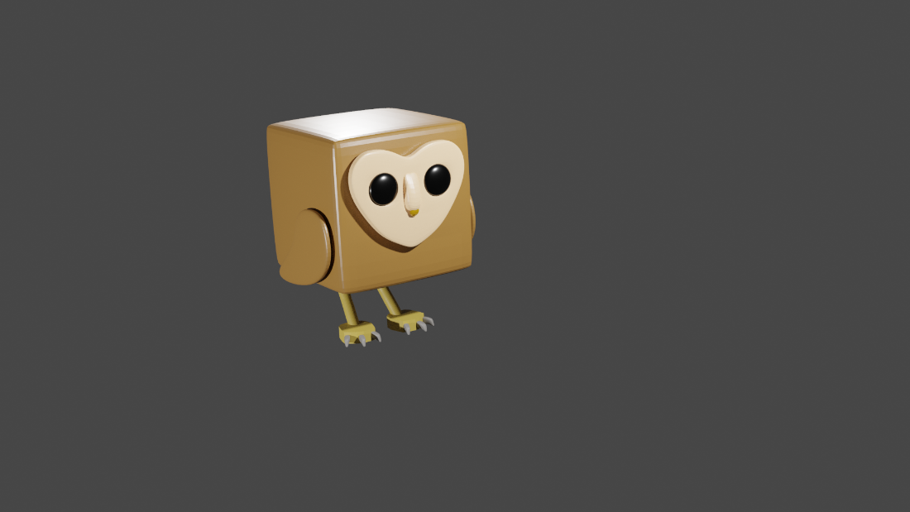
Figure 3 Picture of the Owl³

Controls
The game uses touch controls, with which the player can navigate through different screens (see figure 4) by pressing buttons or the owl.
Players use the keyboard of the phone to write diary entries.
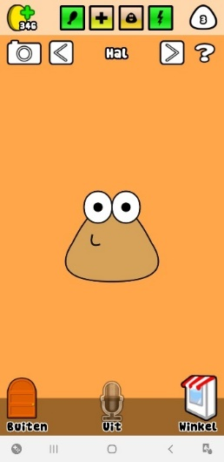
Figure 4 Mobile controls⁴

Platform
Since the game will mostly be played by children and should be very accessible. Due to the program used by the ICT students for developing the game, the game will be constrained to android driven mobile phones and tablets only.

Main Gameplay Concepts

Genre
Players can write diaries, making the game a place for creativity. They can collect stickers which they can add to their diary entries and in gifts. The game has a casual, calming mood

Setting
The game takes place in a room with only a window, through which the players’ companions travel to deliver gifts. The environment is very light colored and bright. Outside the window the player can see some nature with moving clouds in the background.

Game World
The player is bound to the room where they start in. They do not have the ability to speak or interact with anything besides the companion, the sticker book, and diary. Although the player can send and respond to messages, the messages are predefined, as moderation is out of scope for this project.

Mood
The mood can be summarized as “calming”. The game must make the player feel at ease, relaxed, and safe. This is done by the aesthetics (see Aesthetics). By making the player feel this way, a safe environment is created where the player can share their problem, be seen and feel less lonely.

Theme
The theme of the game is a safe space. Anonymity is a very important principle in the game. Without knowing who the player sends their problem to, anonymity can give the player the courage to send it with the underlying thought “I have nothing to lose by sharing”. Because the game’s messaging system is based on predefined messages and stickers, the player will not get hurt when receiving replies and gifts.

Mechanics
- Writing diary entries (add an emoji option: happy, neutral, sad).
- Reading diary entries.
- Sending gifts to other players.
- Receiving gifts from other players.
- Selecting a sticker to be included as a gift with a motivational message.
- Send request messages through pre-defined messages.
- Read the motivational message included with the received gift.
- Open the received gift.
- Customize the sent gift by changing the color of the ribbon and gift box.
- Receive a selected sticker that is in the gift.
- Customize the companion with customization options.
- React to received gifts by sending a heart back to the sender.
- Keep the received messages stored.
- Be able to remove received messages.

Dynamics
- Write diary entries to keep a log about their day-to-day activities and events.
- Read the dairy entries written in the past.
- Picking predefined text for their motivational text list.
- Reading a backlog of the received messages, like a mailbox inbox.
- Choosing from predefined messages.
- Customize the design of the gift box.
- Customize the companion with colors.
- Player can choose a sticker to gift.

Aesthetics
- Personalizing the character
- Calming mood
- Soft, smooth cartoony theme
- Upbeat/cheery music (lo-fi)
- Stickers sorted by colors

Stickers
Stickers to include as a gift with motivational messages.

Figure 5 Heart sticker⁵

Figure 6 Loved sticker⁶

Figure 7 Notes sticker⁷

Figure 8 Present sticker⁸

Figure 9 Sun sticker⁹

Cutscenes
When a player sends out a message, the owl will move to the window and fly away with the message to send it. Some moments later, the owl can be seen flying through the window and moving to its original place.

Similar Products
Kind Words

Inspiration
Kind Words (Room, see figure 6)
Day One (Dairy entries, see figure 7)
Gmail/Yahoo (sending and receiving concept)
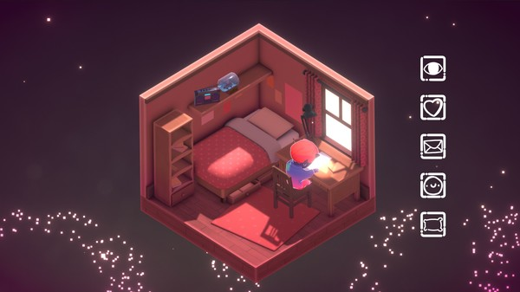
Figure 10 Room of the player in Kind Words¹⁰

Figure 11 Diary entry in Day One¹¹

Literature List
- Dejan Zuza. (n.d.) [Core loop of a game] [Drawing]. Retrieved from https://cityos.io/tutorial/634/Improve-Your-Game-Core-Loop
- Brian Vlaar. (2021-2022) Model of the giftbox [Photograph]. Retrieved from https://cdn.discordapp.com/attachments/910102100128702497/931111308227653632/present.png
- Dylan Pipping. (2021) Owl Model [Photograph]. Retrieved from https://cdn.discordapp.com/attachments/911281342862458881/921043886737080361/unknown.png
- Isabel Pijnenburg. (2021) Main Hall in Poo [Photograph]. Retrieved from https://imgur.com/a/LHkOer7
- Jasper Sijben. (2021) A heart [Drawing]. Retrieved from https://cdn.discordapp.com/attachments/911281342862458881/922887487553150997/Screenshot_2021-12-21_172512.png
- Jasper Sijben. (2021) A being loved emoji [Drawing]. Retrieved from https://cdn.discordapp.com/attachments/911281342862458881/922886974971474011/Screenshot_2021-12-21_172232.png
- Jasper Sijben. (2022) Music notes [Drawing]. Retrieved from https://cdn.discordapp.com/attachments/921166669697667092/932650482181238845/image0.png
- Jasper Sijben. (2022) Present [Drawing]. Retrieved from https://cdn.discordapp.com/attachments/921166669697667092/932657642965463090/image0.jpg
- Jasper Sijben. (2022) Sun [Drawing]. Retrieved from https://cdn.discordapp.com/attachments/921166669697667092/932649304592638002/image0.png
- Popcannibal. (2019) [Room of the Player in Kind Words] [Picture]. Retrieved from https://store.steampowered.com/app/1070710/Kind_Words_lo_fi_chill_beats_to_write_to/
- Day One. (n.d.) [Diary Entry in Day One] [Picture]. Retrieved from https://dayoneapp.com/

